Swineshead Medical Group Saturday Flu Vaccination Clinic
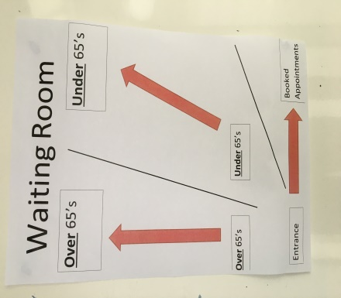
The Flu vaccination clinic was due to start at 8.30am on Saturday 3rd October but was brought it forward by 15 minutes due to the amount of patient’s queueing outside. We could see the patients were trying to socially distance by some people cannot judge 2 metres correctly.
We had three lanes:
- Bookable Appointments
- Under 65 year olds
- Over 65 year olds

We had a one way system and everyone came in the front door but left via one of the fire escapes. We had yellow ‘Wait Here’ dots on the floor so patients kept their 2m distance from each other and we put screens between patients to act as barriers.
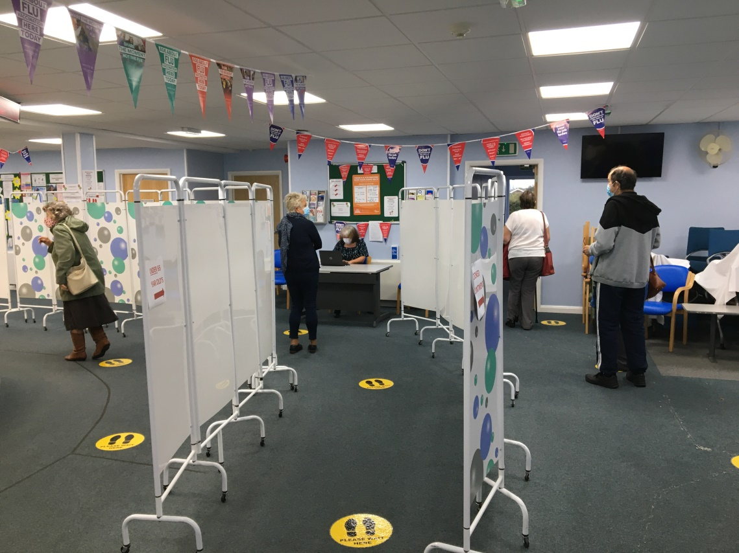
A member of staff was situated at the front door and called patients forward and directed them to the right queue. When we first opened we realised that there were far more over 65 year olds than under so we decided to send some of the over 65 year olds down the booked appointment queue. This sped things up nicely and within 30 minutes we had reduced the queue outside.
We then were able to manage patients as they arrived which worked so much better.
When the patients joined the queue they were met by one of the admin team who registered them in to the relevant clinic on SystmOne.
The admin staff then moved the patient forward to the clinic room where they would have their flu vaccine administered.
In the clinic room there was a Nurse or Paramedic and a HCA. The HCA checked the name and coded the vaccination while the nurse asked the patient the relevant questions and did the vaccination.
The patient was then directed out of the building via the fire doors to the side of the building.
The team on the day worked really hard and were a credit to the surgery.
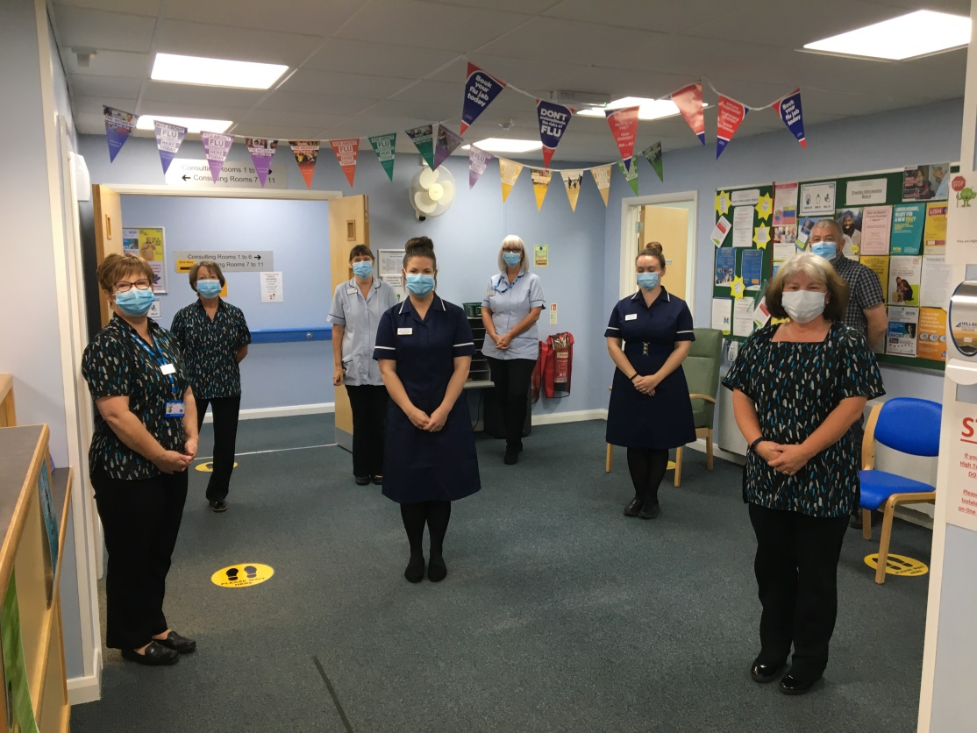

The final count for the day’s work was 742 vaccinated patients which is a tremendous effort.
Thank you!

Prior to the Saturday flu clinics the practice nurses organised the children’s flu clinics. They decided to dress up in child friendly outfits which were made by Charlotte’s mum. They then decorated their visors.
The idea was the very bright and colourful scrubs would help put the children at ease and make the whole experience less daunting.
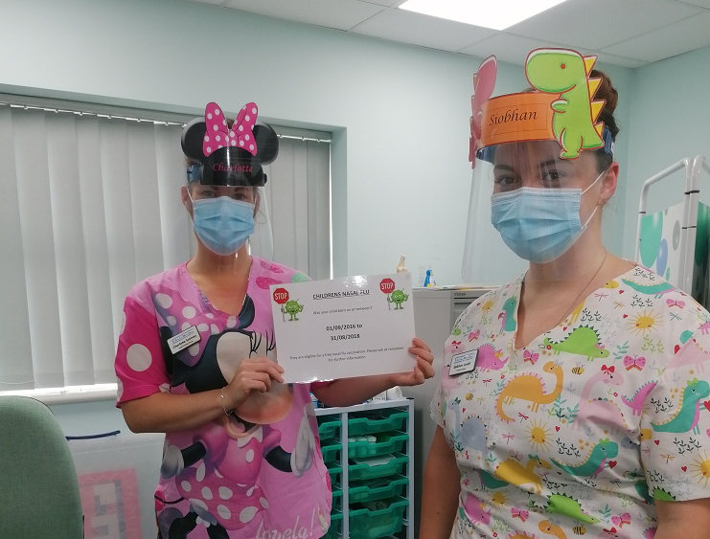

Because Storm Alex was due to hit on Saturday the staff thought the Practice Manager may need some extra PPE when he was outside directing the patients.
The hat made all the difference!
