

**News from Prosperous Communities – Issue 39 – 22.06.27**

**Shine’s June Bulletin**

Please click on the link below for the latest Shine Bulletin

|  |
| --- |
| [cid:image005.jpg@01D88A1C.E52EDA40](https://gbr01.safelinks.protection.outlook.com/?url=https%3A%2F%2Fsway.office.com%2FhGWD9ezmK0ATy0jD%3Fref%3Demail%26loc%3Dplay&data=05%7C01%7CSarah.Grundy%40lincolnshire.gov.uk%7Cae48ac10b91647baf22e08da582ca4f9%7Cb4e05b92f8ce46b59b2499ba5c11e5e9%7C0%7C0%7C637919246015312013%7CUnknown%7CTWFpbGZsb3d8eyJWIjoiMC4wLjAwMDAiLCJQIjoiV2luMzIiLCJBTiI6Ik1haWwiLCJXVCI6Mn0%3D%7C3000%7C%7C%7C&sdata=jHDI72pGp1%2FOVnAX3Scts8JAlwr81%2BNednCCovXN%2FZw%3D&reserved=0) |
| [Shine June Update](https://gbr01.safelinks.protection.outlook.com/?url=https%3A%2F%2Fsway.office.com%2FhGWD9ezmK0ATy0jD%3Fref%3Demail%26loc%3Dplay&data=05%7C01%7CSarah.Grundy%40lincolnshire.gov.uk%7Cae48ac10b91647baf22e08da582ca4f9%7Cb4e05b92f8ce46b59b2499ba5c11e5e9%7C0%7C0%7C637919246015312013%7CUnknown%7CTWFpbGZsb3d8eyJWIjoiMC4wLjAwMDAiLCJQIjoiV2luMzIiLCJBTiI6Ik1haWwiLCJXVCI6Mn0%3D%7C3000%7C%7C%7C&sdata=jHDI72pGp1%2FOVnAX3Scts8JAlwr81%2BNednCCovXN%2FZw%3D&reserved=0) |
| As a network we want to ensure we are sharing as much information with our colleagues as possible. |
| |  | | --- | | [Go to this Sway](https://gbr01.safelinks.protection.outlook.com/?url=https%3A%2F%2Fsway.office.com%2FhGWD9ezmK0ATy0jD%3Fref%3Demail%26loc%3Dplay&data=05%7C01%7CSarah.Grundy%40lincolnshire.gov.uk%7Cae48ac10b91647baf22e08da582ca4f9%7Cb4e05b92f8ce46b59b2499ba5c11e5e9%7C0%7C0%7C637919246015312013%7CUnknown%7CTWFpbGZsb3d8eyJWIjoiMC4wLjAwMDAiLCJQIjoiV2luMzIiLCJBTiI6Ik1haWwiLCJXVCI6Mn0%3D%7C3000%7C%7C%7C&sdata=jHDI72pGp1%2FOVnAX3Scts8JAlwr81%2BNednCCovXN%2FZw%3D&reserved=0) | |

**The Beonna at All Saints Benington**

Please see below job opportunities at The Beonna, together with volunteering opportunities.



**Funding Ready Programme – LCVS**

We at LCVS are really excited to be delivering another set of Funding Ready workshops over July! We enjoy supporting other organisations to learn how to write a successful bid, and there are still a few places free if you’re interested.

Introductory Session - Monday 4th July, 11:30am to 12:30pm.

Workshop 1 - Monday 11th July, 10am to 12:30pm.

Workshop 2 (part 1) - Monday 18th July, 10am to 12:30pm.

Workshop 2 (part 2) - Thursday 21st July, 10am to 12:30pm.

Workshop 3 (part 1) - Monday 25th July, 10am to 12:30pm.

Workshop 3 (part 2) - Wednesday 27th July, 10am to 12:30pm.

The workshops are free and virtual – they are delivered via Zoom, so you can attend from wherever you may be!

All you have to do is fill out the forms below and return them by 30th June – they’ll only take you 5-10 minutes to complete!

Upon completing these forms, you will be signed up for these workshops, and will receive everything you’ll need a few days before each session.

**Still not convinced?** Take a look at our [Funding Ready video and see what previous attendees have said](http://www.lincolnshirecvs.org.uk/wp-content/uploads/2022/04/Funding-Creative-New-V3-Final.mp4).



**Butterfly Release Event – 17th July – 2 pm**

Please see below the poster for the Butterfly Release event which will take place on 17th July starting at 2pm and is a wonderful and special way to remember loved ones, by releasing a butterfly in their memory in the beautiful setting of the hospice grounds. Butterflies are £10 each and can be ordered by visiting <https://www.butterflyhospice.org.uk/events-fundraising> or by calling 01205 311222. Alternatively butterflies can be ordered for release at home for anyone who cannot attend the event.



**Carers First**

Please see below for details of the Carers First drop in to receive information and advice at Boston Library which will take place on 12th July, 2022 between 10 a.m. – 12 p.m.

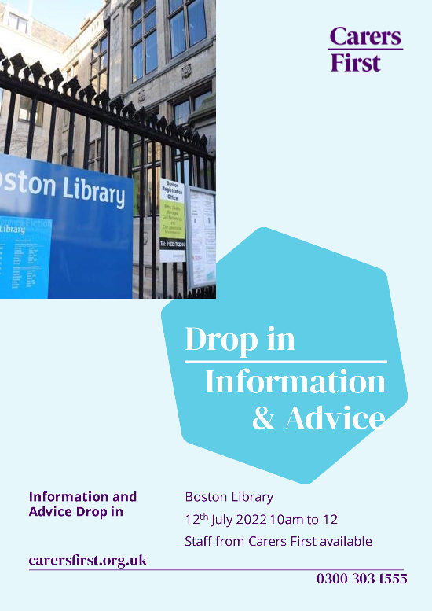

**soundLINCS – Freelance Music Facilitators**

Please see below advert for Freelance Music Facilitators at soundLINCS and contribute to the development of music-making opportunities throughout Lincolnshire and the East Midlands.



**Covid Vaccinations – It’s not too late!**

Against a backdrop of a rise in covid cases nationally, Lincolnshire people are being reminded to get their covid vaccinations, particularly anyone aged 75 and over as well as those who are immunosuppressed.

The Office for National Statistics has reported an increase in the percentage of people testing positive for covid, likely caused by Omicron variants BA.4 and BA.5, and data from the UK Health Security Agency has revealed hospital admission rates are increasing, although admissions to intensive care units remain low.

“I realise that getting a covid vaccination may not be everyone’s top priority during the summer, but if you are eligible for a covid vaccination, particularly a spring booster – for those people who are 75 or over, or immunosuppressed –please get vaccinated and if you know someone else who’s eligible, please encourage them to get vaccinated,” urges Rebecca Neno, Director of Covid and Influenza Vaccination Programmes, NHS Lincolnshire CCG.

“The vaccination programme has prevented thousands of people from getting seriously ill with covid and/or being hospitalised, including many people in Lincolnshire, and now that cases are rising again it is vital that everyone eligible gets their latest jab as soon as possible, in order to have the maximum protection possible against covid.”

In addition to spring boosters for people aged 75 and over and those who are immunosuppressed, there is still an ‘evergreen’ offer available for covid vaccinations in Lincolnshire, which means anyone who is yet to be vaccinated can get their 1st, 2nd, or booster vaccinations.

“It’s not too late to get your vaccination and now that summer is here and we’re all thinking about travelling, it remains just as important – if not more so – to make sure you’re up to date, in terms of having the full course of covid vaccinations you are eligible for,” adds Rebecca.

“We know the protection offered by the covid vaccines deteriorates over time and that’s why it’s vital to get all of the covid vaccinations you are eligible for.  This is especially the case if you are 75 or over or immunosuppressed and eligible for a spring booster.  Also, don’t forget you will need about three months for your immune system to get the full benefit from the vaccination, so that you have the maximum protection, so please either book an appointment or come and see us at one of our pop-up vaccination sessions.”

The pop-up vaccination sessions (listed below) do not require an appointment, you can just turn up – for the latest information on the locations and dates/times of these sessions, please visit [www.lincolnshireccg.nhs.uk/grabajab](http://www.lincolnshireccg.nhs.uk/grabajab).  Alternatively, appointments for covid vaccinations can be booked online using the [National Booking System](https://www.nhs.uk/conditions/coronavirus-covid-19/coronavirus-vaccination/book-coronavirus-vaccination/book-or-manage-a-booster-dose-of-the-coronavirus-covid-19-vaccine/) or by calling 119.

The vaccination teams will be running the following pop-up walk-in sessions:

**Saturday 2nd July** at **Stickney Car Boot Sale,** Main Road, Stickney, Boston PE22 8AG, between 8.30am and 12pm for spring boosters for people aged 75 and over and anyone aged 18 and over who is currently immunosuppressed.

**Saturday 2nd July** at **Staples,** Marsh Farm, Sea Lane, Wrangle, Boston PE22 9HE, between 2pm and 5pm for spring boosters for people aged 75 and over and anyone aged 18 and over who is currently immunosuppressed.

For more information visit [www.lincolnshireccg.nhs.uk/grabajab](http://www.lincolnshireccg.nhs.uk/grabajab)

**EDAN Lincs Domestic Abuse**

In the last year they have helped hundreds of people across the whole of Lincolnshire who suffered domestic abuse: they supported 123 adults and 114 children in their refuge emergency accommodation across Lincolnshire. Their Outreach team has supported 3990 victims of domestic abuse in the community including 475 high risk cases via their IDVA support. 21 years providing support, advice and safety to men, women and children in Lincolnshire who experience domestic abuse!   
They have a Birthday fundraiser they are running on their Facebook page [**https://www.facebook.com/donate/714679776522991/**](https://gbr01.safelinks.protection.outlook.com/?url=https%3A%2F%2Fwww.facebook.com%2Fdonate%2F714679776522991%2F%3F__cft__%5B0%5D%3DAZVillIObOA_-rDHgp06MYBZFd5rGnDSe6a6bxMnGCVB1ommv_NV4qb-gxY_1DKAP6buunte9Azv_ULQEhOyNHYXFTY1mavn8IcLFLLeX7fIud_mTHgITAN8tCYSY-jH4Ri4JP0yb7d7sMP5nVbF3r4YNznULyCG-ipn3uFLybVuuQg8p9CdGMBhF0V4YpKklXAPQNLbpPtHPMGriXHbbFws%26__tn__%3D-UK-R&data=05%7C01%7CSarah.Grundy%40lincolnshire.gov.uk%7C2b60e44d69804bd1762308da59b4dcc6%7Cb4e05b92f8ce46b59b2499ba5c11e5e9%7C0%7C0%7C637920930577944709%7CUnknown%7CTWFpbGZsb3d8eyJWIjoiMC4wLjAwMDAiLCJQIjoiV2luMzIiLCJBTiI6Ik1haWwiLCJXVCI6Mn0%3D%7C3000%7C%7C%7C&sdata=eJsIn5YYjVKnGSyBRvMC%2B6AGYyLVpBvnDABHaczgpj4%3D&reserved=0) - money raised will go to support victims of domestic abuse in Lincolnshire!

