The Swineshead Medical Group

**June 2021 Newsletter**

**Telephone Consultations**

We will continue to use eConsult as the main method of patients contacting the surgery. You can access eConsult via the practice website. [www.swinesheadmedicalgroup.co.uk](http://www.swinesheadmedicalgroup.co.uk)

To access eConsult please just follow the prompts.

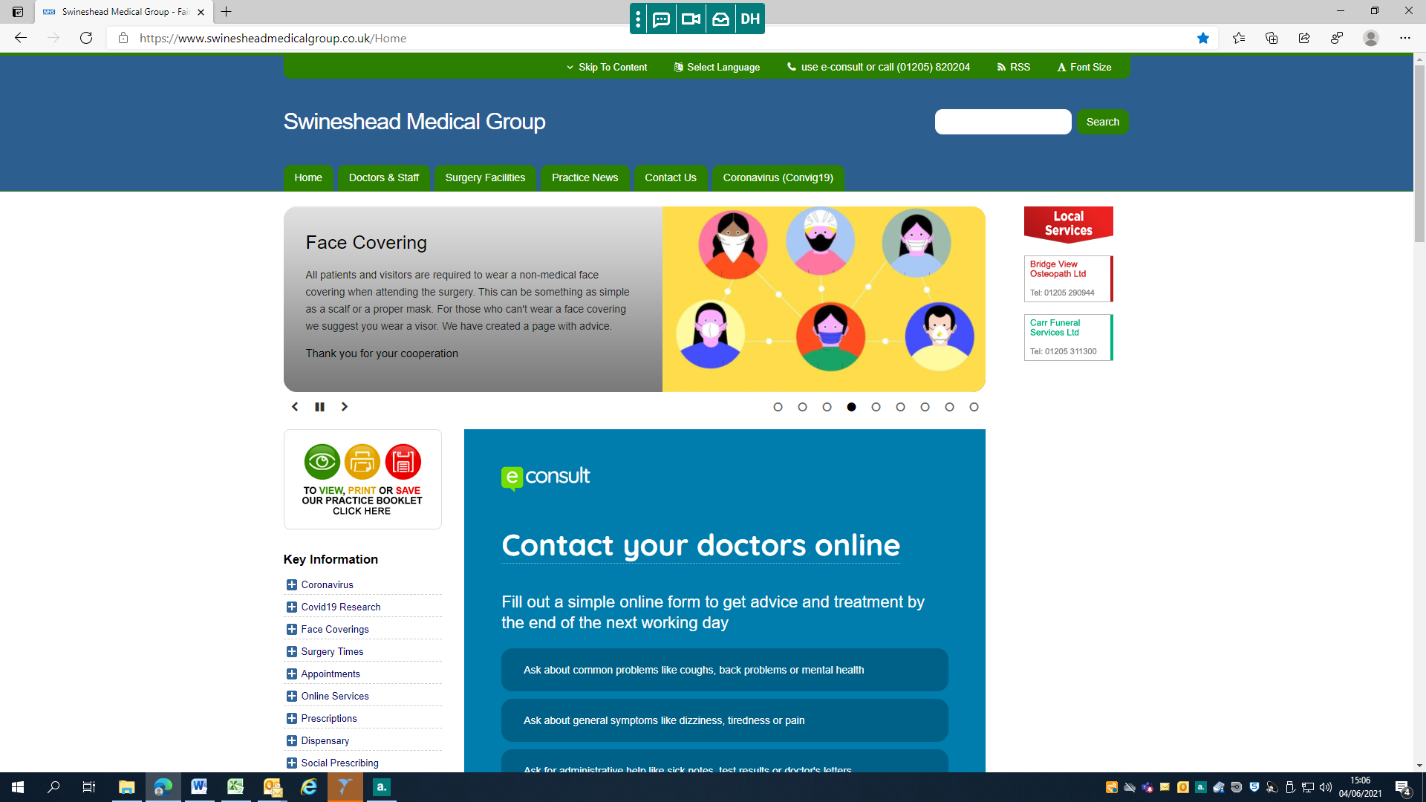

The On-Call clinician will allocate your submission and the appropriate clinician who will then either; email you with advice and guidance, call you on the number you have given on the eConsult and have a telephone consultation, do a video call to patients with a smart phone or arrange for you to come in and be examined and seen face to face.

**The majority of our consultations are over the telephone.** This is because we do not want to put you, other patients or staff at risk of Covid unnecessarily. Some patients think this is the way forward but we know some patients find this very difficult and want to be able to see the doctor face to face. **If during the initial telephone consultation the clinician decides they can only treat you by seeing you face to face they will arrange for you to attend the surgery.**

**Are Your Contact Details Up To Date**

We are constantly trying to keep our records up to date but if you change your phone number or move house please let us know by telephoning reception.

**Covid Vaccinations**

Many of you will be aware that **Swineshead Medical Group** has been working with **Greyfriars Surgery** and **the Sidings Medical Practice** to offer Covid Vaccinations to all eligible patients within the Boston Locality on behalf of the **Boston Primary Care Network**.

The vaccination hub, at the Sidings Medical Practice, came into being on 6th January 2021. Due to our busy work commitments we have just finished delivering the vaccines and are now handing over to the Princess Royal Sports Arena (PRSA) who will continue to deliver vaccinations for patients in our area.

The 3 practices came together and have worked extremely hard over the past 5 months and have delivered over **30,000 vaccinations**for all 6 Boston GP practices. This includes care home residents, housebound patients and other patients from the most clinically vulnerable groups as identified in national guidance and NHS Staff who work in the local area.

Rest assured, if you are eligible for a vaccine or become eligible for a vaccine, you will be contacted and sent a link to book an appointment at one of the local vaccination hubs.

If you need to book a vaccination we advise you to call **'119'** who will be able to book you an appointment.

We were able to facilitate the Vaccination hub due to the continued hard work of our teams, both clinical and non-clinical staff. Working long hours and also providing cover on their days off to enable us to vaccinate as many patients as our vaccine supply allowed. We should also give acknowledgement to our fantastic team of volunteers, supporting our staff, providing car park cover, directing patients and numerous other duties. We truly could not have done this without them.

The community spirit and gratitude has been overwhelming. We have received letters and cards of thanks as well as numerous donations and gifts ranging from hampers, cakes, chocolates, flowers, the list goes on.

We are truly grateful to all that have made such nice gestures and it really makes all the hard work feel worthwhile.

Keep safe and together we will beat the pandemic.

**Swineshead Dispensary**

Open Monday to Friday 9.00 a.m. to 1.00 p.m. and 2.00 p.m. to 6.00 p.m.

We can only dispense medication to patients who live more than 1 mile from a community pharmacy. Please allow 72 hours (***3 working days***) from ordering before coming to collect medication. You can order repeat prescriptions by telephoning **01205 822411** (24 hour service) or online if you are registered for this service. If you run out of medications when the surgery is closed you can obtain a 3 day ‘emergency’ supply from a community pharmacy on production of your repeat medication slip; there is a charge for this service.

We can provide a delivery service for those patients ***who have genuine difficulty collecting their medications from the surgery***. Please ask for details at the dispensary.

**Textual Reminder Service**

|  |  |
| --- | --- |
| Because everyone is so busy we can offer a textual reminder service. If you book an appointment we will text you the day before to remind you. You can sign up at reception for this free service | [Related image](https://www.google.co.uk/url?sa=i&rct=j&q=&esrc=s&source=images&cd=&cad=rja&uact=8&ved=2ahUKEwiak-ikw_TfAhXjA2MBHcKZBSAQjRx6BAgBEAU&url=https://www.patientcomms.co.uk/&psig=AOvVaw095nt5OWuYCz5Ct7CQpmBw&ust=1547804448514195) |

**New Staff**

During the past year we have welcomed new members of staff to the team which include Andy Robinson as our Extended Scope Practitioner, Debbie Cartwright as our new Advanced Nurse Practitioner and Siobhan Lovett who is a Practice Nurse.

We recently advertise and recruited to a new Phlebotomist post and would like to welcome Abby Lee. Abbey will be working from 8am to 1pm , Monday to Friday.

**Training Practice**

Swineshead Medical Group is an accredited training practice. We host qualified doctors who are undertaking their GP training. Dr Whitfield and Dr Alam are the current GP Trainers. Dr Gabriel Oyelayo started with us in April and will be with us until August

We also continue to host Foundation Year 2 doctors under Dr Kelly’s supervision. These doctors change every 4 months. The Practice has welcomed Dr Thomas Nicholl and Dr Emma Turner.

Please welcome these doctors to the practice as they are the future of the NHS and hopefully we can show them what a wonderful place Lincolnshire is to live and work.

**Primary Care Network (PCN)**

|  |  |
| --- | --- |
| We continue to work with our local PCN (which is 6 local GP practices) to improve local services. The PCN has employed new pharmacists who are working in practices, a care home care coordinator and we are in the process of recruiting another six care coordinators, one for each practice. We are also planning to have six new nurse associates, again one for each practice. | Boston Pcn smaller logo |