

**News from Prosperous Communities – Issue 43 – 26.07.22**

**NHS Lincolnshire Integrated Care Board Engagement Bulletin – Issue 25**

Welcome to the new look Engagement Bulletin!

This has been created using Microsoft Sway to provide a more interactive newsletter and because some of you had problems opening the previous versions. This is a commonly used and trustworthy software and we are trialling it to see what you think.

* To open simply click the link ‘Go to this Sway’ below.
* Once the Sway has opened you can change the view to ‘Accessibility view’ by clicking on the 3 dots at the top right of the page.
* If you need to enlarge any of the images simply click onto the image and it will open in a new window.
* When you select a link, a box will pop up advising that you are being directed away from sway and whether you trust the content. Click ok and the page will open in a new tab.

|  |
| --- |
| [The Contributor](https://sway.office.com/bzsC0bYBc41137MB?ref=email) |
|  |
| |  | | --- | | [Go to this Sway](https://sway.office.com/bzsC0bYBc41137MB?ref=email) | |

**Sing-a-long around the Beach**

The Sing-a-long around the beach is taking place today! 2pm to 4pm at the Central Park Beach Area. Free event for those over 55 and those living with dementia.

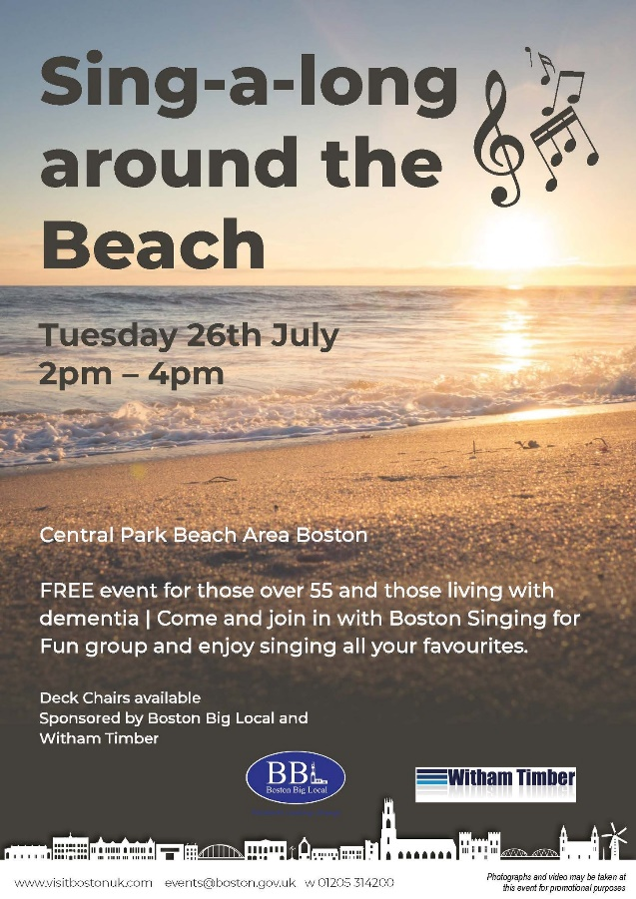

**Fun in the Sun – This Thursday**

Free event for those living with additional support needs. Thursday 28th July, 1pm to 3pm at Central Park Beach Area.

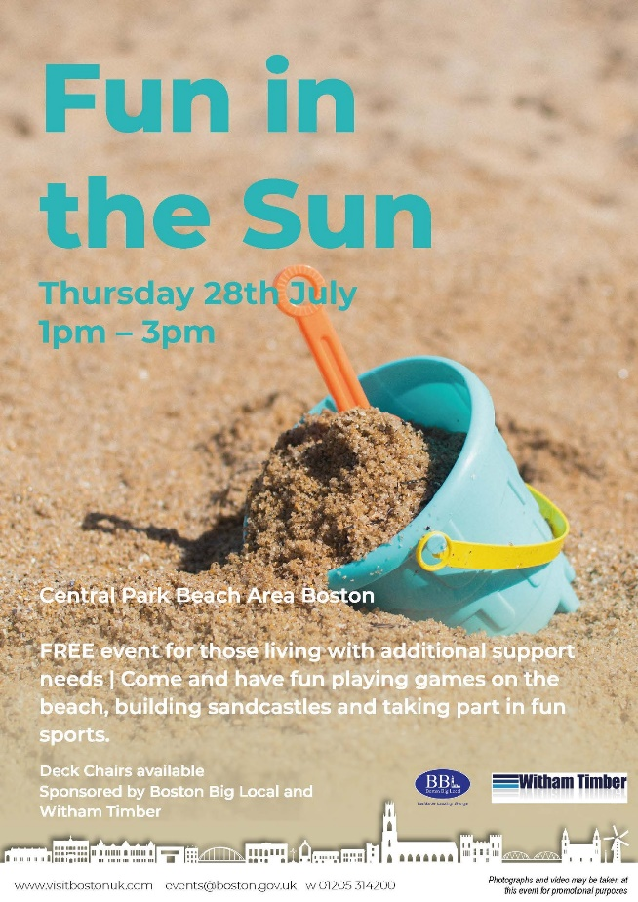

**Fun and Free Games**

Looking for fun and free kids' activities? Play these Disney-inspired games! Find a game here: [https://www.nhs.uk/healthi.../activities/10-minute-shake-up/](https://www.nhs.uk/healthier-families/activities/10-minute-shake-up/?fbclid=IwAR2ILVZdu3iFTlepXy0hI6j4kpvN2qGEKVqosbD3hZnLteG58ULDn1c_KPo)



**Carers – Surviving Summer Course**

Please see below details of a Carer course being run by the Recovery College.

Please contact the Recovery College on Email: [lpft.recovery.college@nhs.net](mailto:lpft.recovery.college@nhs.net) Tel: 01522 518500 to book onto the course.



**5K Your Way Move Against Cancer**

Join us this Saturday in Boston for the 5K Your Way Move Against Cancer monthly event! It’s free to take part and you can run, jog, walk – we’ll see you there at 9am!

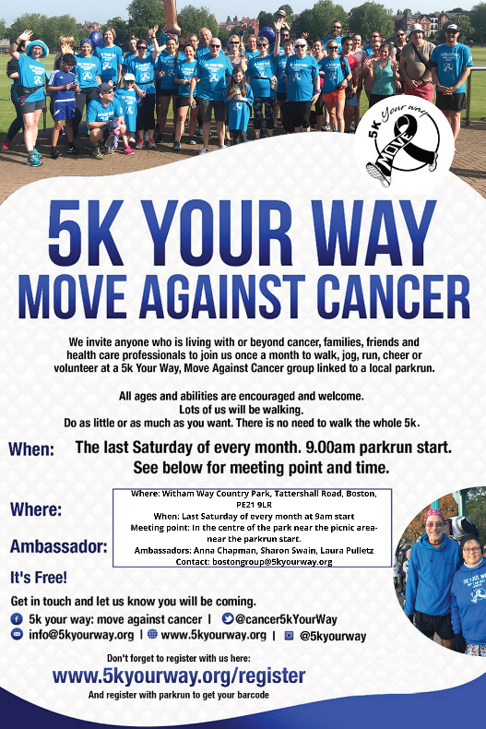

**Boston Operatic Society Musical Theatre Group**

After the lockdown years and the lack of opportunities to enjoy live theatre, BOS Musical Theatre Group (formally Boston Operatic Society) are thrilled to be back. After the success of their fantastic production of Sondheim’s Company in April, BOS Musical Theatre Group are now bringing another production to the Blackfriars Stage this August, sure to delight audiences of all ages. Step in Time takes us on a journey through the decades, featuring songs from musicals set in the 1910s right up to the modern times. You will find yourself tapping your feet and singing along to numbers from Anything Goes, Kinky Boots, South Pacific, Wicked, Kiss me Kate, Dear Evan Hansen, Chicago, Singing in the Rain, and so many more. With a cast of over 30 talented locals, high octane dance routines and some mind-blowingly good vocals, this show promises a fantastic night out.

Step in Time is being performed at *Blackfriars Theatre, Boston* on August 5th and 6th 2022. Tickets can be booked online or via the box office.

Contacts:

Jenny Cartwright: [bosmusicaltheatregroup@gmail.com](mailto:bosmusicaltheatregroup@gmail.com) or 07411 330035

Blackfriars Arts Centre: <https://www.blackfriarsartscentre.co.uk/Step_in_Time> or 01205 363108

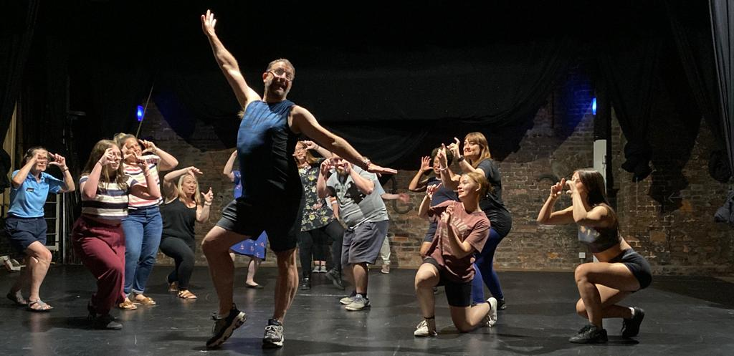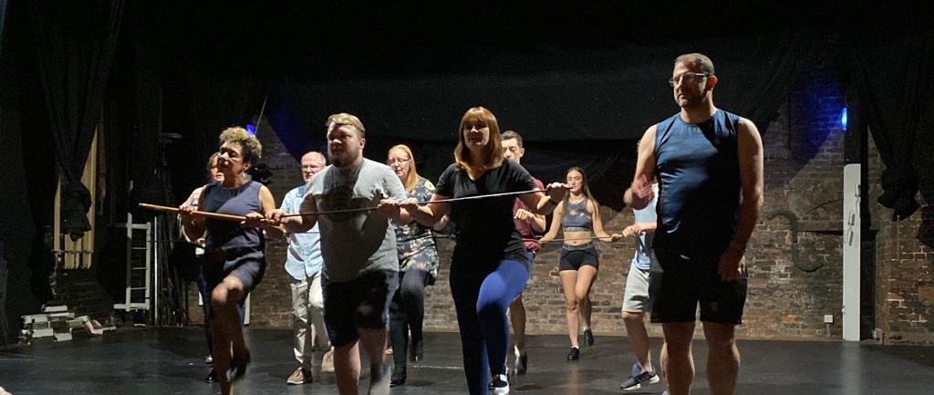

**Boston Market – 10th August 2022**

Please see below details of a stall which will be available on Boston Market on the 10th August suggesting various ways of getting involved and making a difference in your community. There will be lots of children’s activities available including free face painting and balloon modelling.

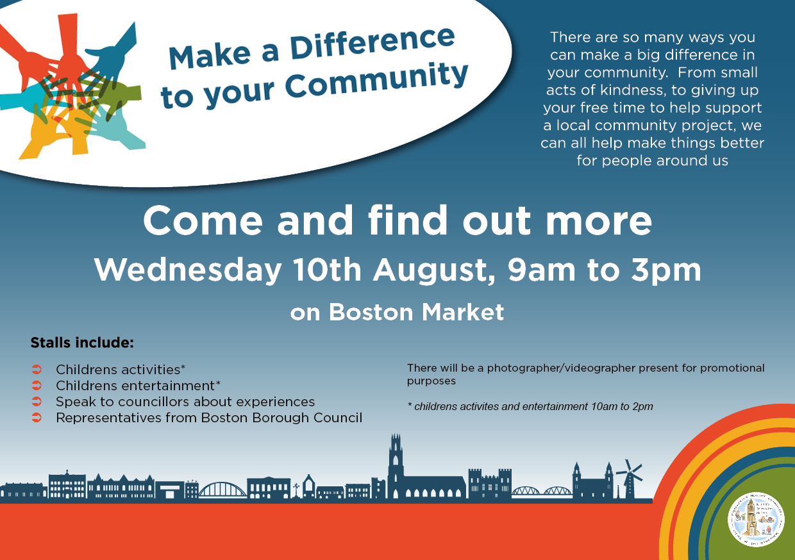

**Forum Tour**

Boston are part of Zest Theatres 'The Forum' tour this summer and will be in Boston Market Place from 31st August – 3rd September. Fuelled by the words of young people from across Lincolnshire, ***THE FORUM***will tour 5 x Lincolnshire towns this summer. This pop up town square has been colourfully created to bring communities together to contemplate a better future inspired by Lincolnshire’s young people.

Click on link below for further details. Find out more about [Zest Theatre](https://www.facebook.com/zesttheatre?__cft__%5b0%5d=AZUmrq-MKRRkFH-feMNUn8CiXB1eUhLcKMgkB37fWL8kdc6MlcATIfExsSacSSt1RnNGW90TeKAf32Jx4pMoR_PNT2fZmggX6WlFWGfhw_DPbrCQvCYx01n_QulSWcFOWc1bk7t8rXyDvVhwVi7UGHS002E8iTr3Fyv7TwD0zpdZsA&__tn__=-%5dK-R) and the upcoming tour at [https://zesttheatre.com/blog/18/7/2022/announcing-the-forum](https://zesttheatre.com/blog/18/7/2022/announcing-the-forum?fbclid=IwAR3wQZyfUw7dTKYUuRM-V0h5IEOY2MMWUCm6sfQZJ4qX7iQ_uMxir4wx550)



**Social Prescribing Link Worker**

LCVS are looking for organised, self-motivated, and confident individuals in Spalding, South Lincolnshire Rural & Stamford & Bourne to join their established Social Prescribing teams. Please click on the following link for further details:- <https://lnkd.in/eujXDzXv>