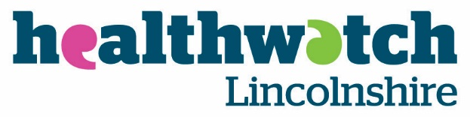

Press Release: For Immediate Release – 30.06.22

Healthwatch Lincolnshire is proud to publish its annual report for 2021-2022. In what has still been a challenging year as the pandemic continued, Healthwatch have continued to put Lincolnshire residents at the heart of the Health and Social Care Services they receive.
Highlights
- 5528 people shared their experiences of Health and Social Care Services with Healthwatch Lincolnshire, helping to raise awareness of issues and improve care.

- 1702 people came to them for clear advice and information about topics such as mental health and Covid-19.

- They have seen 35,050 page views on their website and have reached an incredible 543,557 people through Facebook.

- They are lucky to have 40 outstanding volunteers, who gave up 1,053 hours to make care better for our community.
Healthwatch fundamentally believe that together they can give a stronger voice to the residents of Lincolnshire in relation to what matters to you about your Health and Social Care Services, please keep sharing your experiences and stories with them. Healthwatch Lincolnshire would like to thank everyone who has supported their work over this past year including their amazing staff and volunteers.
A download link to the report is here: https://www.healthwatchlincolnshire.co.uk/report/2022-06-30/annual-report-20212022-championing-what-matters-you
If you need the report in another format or would like to discuss anything, please email info@healthwatchlincolnshire.co.uk or call 01205 820 892.
You can help make Health and Care Services better by sharing your experiences and ideas.
Talk to us, you can call on 01205 820 892, email info@healthwatchlincolnshire.co.uk or visit www.healthwatchlincolnshire.co.uk/have-your-say

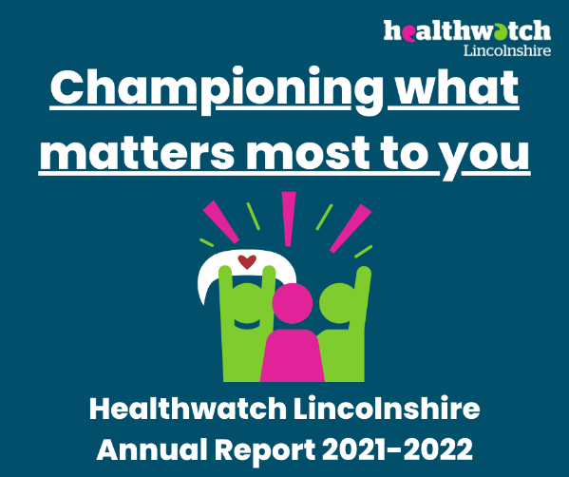
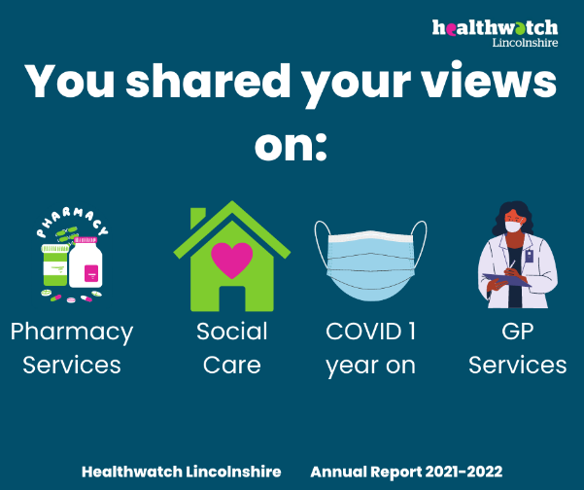

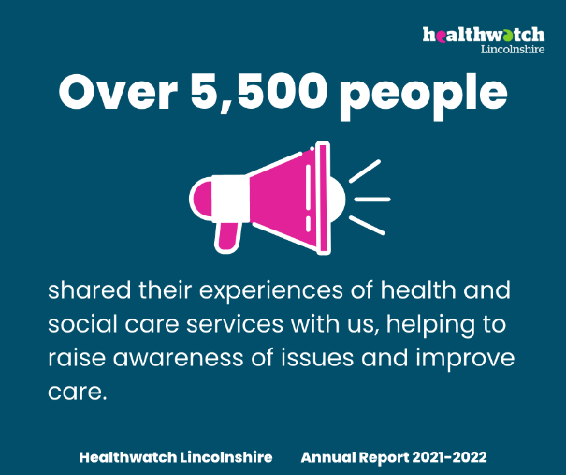
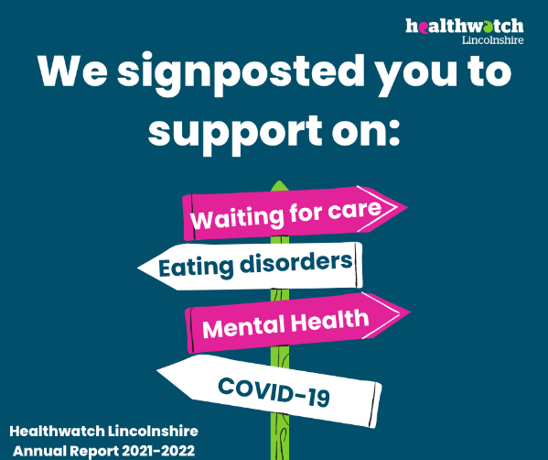
ENDS

Notes for the Editor

HEALTHWATCH LINCOLNSHIRE
Healthwatch Lincolnshire is one of 152 local Healthwatch groups set up by the Government as part of health reforms set out in the Health and Social Care Act in 2012. Its job is to ensure that the voice of patients, users and the public is at the heart of NHS and care services. Healthwatch Lincolnshire gathers patient views, represents those views to local NHS organisations and makes sure they are taken account of.

1. Healthwatch Lincolnshire is the only independent consumer watchdog for Health and Social Care services in Lincolnshire. It:

- Monitors and influences local health and social care provision.
- Harnesses the expertise of local communities, charities, and voluntary organisations.
- Encourages people to share their views with and about the services they use.
- Gives feedback to health and social care providers as well as to Healthwatch England.
- Signposts people to information about health and social care services in Lincolnshire.
- Provides information about what to do and who to talk to if things go wrong.
- Above all, ensures that the public's voice is heard - and responded to!

