**************************************************************************

The Swineshead Medical Group PPG
***************************************************************************
Draft Minutes Swineshead PPG Meeting 21st November 2023 5pm

Minutes of the meeting of Swineshead Medical Group PPG held at Fairfax House in the evening of Tuesday 21 November 2023.

At 1700 hr The Chair greeted everyone present and those on Microsoft Teams and indicated that the agenda items would be taken in a separate order as Mr David Harding Practice Manager was currently in a meeting and would attend in due course.

1/ Apologies were received from S. Cannizzaro, G. Carrot, R. Decamps, J. Gibson, S. Gibson, M. Parkinson, D Ginns, P Marshall, S Ewins.
The Chair indicated that there had been four resignations.

2a/ A general description of Breast Cancer Awareness Day with Becky Avery New Cancer Care Coordinator was outlined. The Chair spoke of Becky being an asset to the practice. Area Cancer co-ordinators had been present. Information had been shared. Over £300 raised for Breast Awareness Charity.
The matters of funding and criteria for screening were considered. Concerns over wider issues, e.g., prostate cancer were discussed.

2b/ Swineshead PPG Facebook group had been successfully launched with 60+ members so far. Postings are regularly updated with interesting facts that will support patient wellbeing initiatives going forward with events being held in the surgery and community.

The Chair Ava had also launched Swineshead PPG Facebook Events Group on Facebook that interacts with other Event groups in the surgery community as we all work together for the benefit of patients and the community we live in.

2c/ Ava Chair outlined preparations for the Christmas Meet and Greet Fundraising event on 12 December. 4 hampers for all the family had been purchased in (Oldrids) Downtown which will be for raffle prizes. At £1 per ticket.
The event will begin at 10am to 4pm.
This will be a Meet and Greet PPG Members/Surgery Staff and Patients; the aim will be to raise awareness of the group and raise funds for Privacy Screens for new Patient Use Blood Pressure Machine in Surgery Reception.
Tea, coffee, and mince pies will be available. (Some Home Baked)
AHB will be responsible for buying Tea, Coffee Milk and for the event itself.
Stand will be set up by Fairfax House staff early in the morning of the event, with grateful thanks from Ava Chair.
Ava Chair along with Vincent Chambers Secretary will run the event and further help was sought. S. Thompson and B. Connolly offered to attend for part of the day. Anna Chapman Vice Chair offered to support as well. Graham Carrot and his wife Pauline also offered to help post PPG meeting plus bake yummy homemade mince pies.

It was agreed that the draw for the raffle prizes would take place the following day with winners advised by telephone. Congratulations to all those that win. Ava Chair.

2d/ With the arrival of David Harding Practice Manager minutes of the previous meeting (19th September 2023) were viewed and agreed unanimously as an accurate record.

2e/ David Harding Practice Manager, wished to consider the matter of the £3000 used to facilitate purchase of the new van for delivery of medications to housebound patients covering a wide area outside Swineshead. From Heckington to Gosberton Clough and all the little villages in-between. Surgery Rural Outreach to Patients.
This had been agreed at the previous meeting but DH was to give further clarification.
A replacement was required if delivery to the 250 + patients who were unable to leave their house was to continue. Cancelling delivery was an option but not recommended as it was not in the best interests of anyone. An electric vehicle had been declined as too expensive as had an equivalent diesel. Eventually a second-hand diesel had been purchased for £18 000, with £4000 coming from insurance and £11 000 from Practice Partners

Our £3000 donation had completed the total. There had been a 20% tax refund. DH stipulated that anyone using the service had to meet strict criteria. The matter would be posted on Facebook. (Posted on Facebook sites by Ava Chair that cover the area the surgery serves) Use of the group’s £3000 (sitting in the account, unused, for some time) Ava HB Chair said she supported the donation 100% and it was agreed unanimously after being proposed by S Thompson and seconded by R Bell.
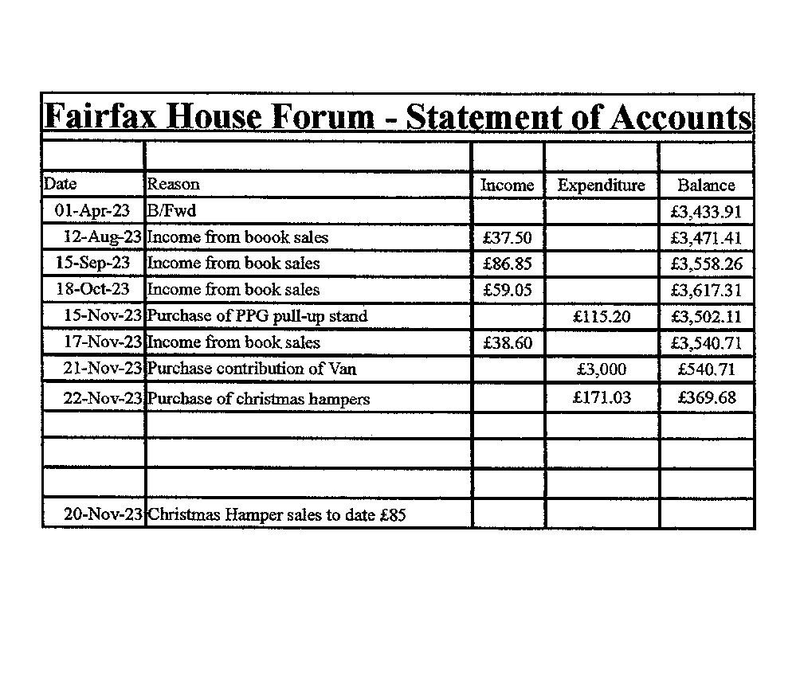
Book sales in surgery bookcase in Reception are going well. If you have any nearly new books you would like to donate, we would be grateful to receive them at the surgery. Every donation goes towards helping patients.

2f/ Annual Patient Review details were outlined by DH. Reference was made to different types of reviewed conditions. When asked, DH stated that patients of sound mind could not be forced to attend. Others would be reviewed with carers. K. Burgess wondered if any support was offered to those not attending. DH made mention that three letters were sent. Nothing further could be done other than visits being made to patients with learning disabilities.

2g/ Ava Chair was pleased to announce that our PPG Roll Up
banner had been manufactured and was of excellent quality. This will be in Surgery Waiting room and taken to Community events across the area the surgery serves.

3/ Practice Manager Update
DH furnished a sheet outlining all current issues. Such is attached.
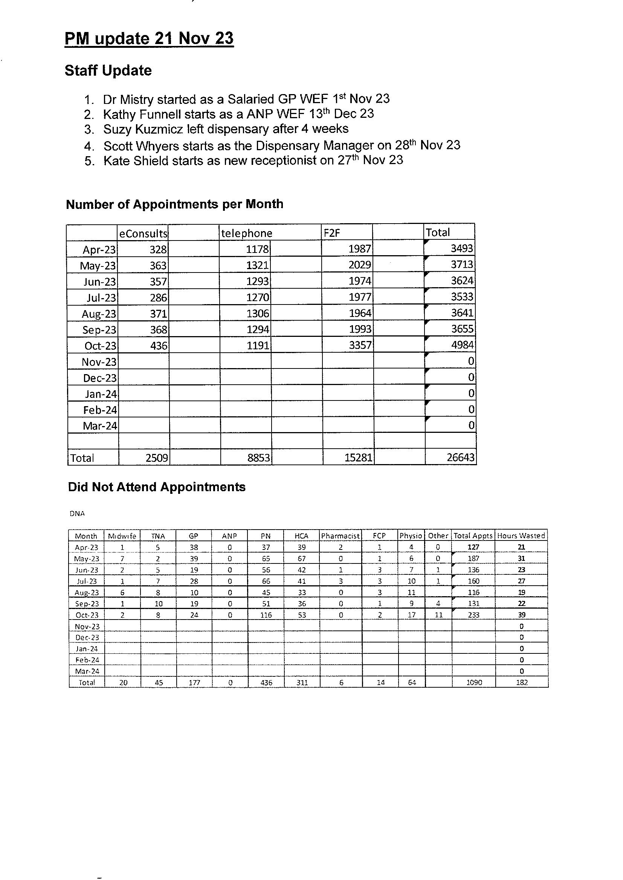
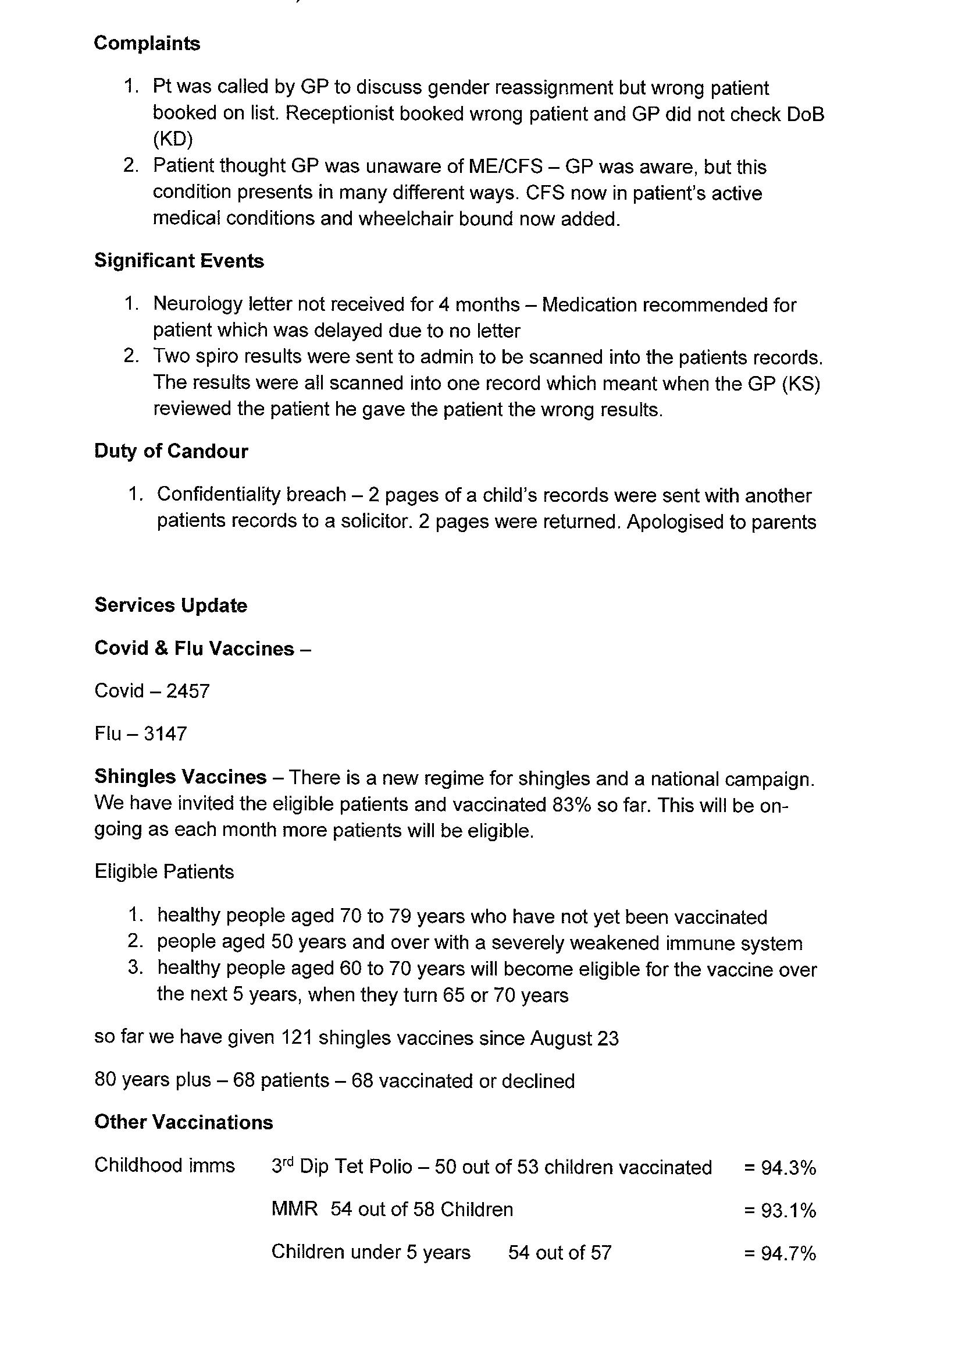

Responding to queries DH stated that eConsult were not oversubscribed. Total consultations of all types were governed by clinician availability, not demand. Swineshead Medical Group (SMG) had one of the best rates of consultation with all patients receiving attention within 24 hours. He added that Saturday surgeries were being conducted by an outside agency, not SMG.

4/ Any Other Business
None was forthcoming. As a result, the chair again thanked all for attending, closing the meeting at 1840 hr.

Date of Next Meeting: Tuesday 16th January 2024 5pm
Speaker on Social Prescribing will be in attendance.

V.A.C.
22.11.2023

